

MASENO UNIVERSITY

SCHOOL OF COMPUTING AND INFORMATICS

**DEPARTMENT OF INFORMATION TECHNOLOGY**

**ONLINE CROP FARMER’S ADVISORY SYSTEM**

**MALON KIPLETING**

**CIT/00159/019**

**CIT 409: INFORMATION TECHNOLOGY PROJECT I**

**PROJECT REPORT SUBMITTED TO THE SCHOOL OF COMPUTING AND INFORMATICS IN PARTIAL FULFILMENT OF THE REQUIREMENTS FOR AWARD OF THE DEGREE OF BACHELOR OF SCIENCE IN INFORMATION TECHNOLOGY**

**MAY, 2023**

**MASENO UNIVERSITY**

**P.O. BOX PRIVATE BAG**

**MASENO, KENYA**

# **DECLARATION**

I declare that this report is my original work. Where there is work or contributions of other individuals, it has been duly acknowledged, and relevant citations are given. To the best of my knowledge, the material herein has yet to be previously presented to any other academic institution for examination, degree award, or another award (s).

**RegNo ………................Name……………………………… Signature**……… **Date**:………

This report has been submitted for examination with my approval as the university supervisor.

**Supervisor Name……………………………………Signature**……… …….. **Date** ………

**Supervisor Name……………………………………Signature**……… …….. **Date** ………

# DEDICATION

This report is a special dedication to my family, lecturers, and colleagues whose love, understanding, guidance, and encouragement have made it successful. It is also a dedication to the School of Computing, Maseno University, for their sacrifice to ensure I have the hands-on skills required in the real world.

# ACKNOWLEDGEMENT

God has been part of the whole thing. I also sincerely thank my supervisors, Mr. James Chamwama and Mrs. Violet Settim, for their guidance, comments, and suggestions throughout this project. To my lovely mother, thank you for the support and love. To my colleagues, thank you most sincerely for the critique, which improved my work.

# **ABSTRACT**

This report investigated the various barriers crop-planting farmers in Kenya encounter when looking for online agricultural guidance. Most of these sites only provide farmers with rudimentary tools, often inadequate to their needs. The overall objective of this project is to develop a web-based crop farmer's advisory System for crop farmers based on best practices. The high cost of available farmer's advisory systems makes them inaccessible to small-scale farmers, who cannot afford them due to the limited number of agricultural experts available to provide advice. Specifically, the project was required to; identify the modules of the automated farmer's advisory System, design the prototype, code the designed prototype, and test the developed prototype. Software testing was used to determine if the software product complied with expectations and was error-free. It entailed using human or automated software to assess one or more properties of interest. The goal of software testing was to find flaws, gaps, or unmet requirements compared to the needs as written. The design was done through Entity-Relationship Diagrams (ERD) for the database, Use Case Diagrams for identifying the interactions between the System and its actors, and an Activity Diagram to model the dynamic aspects of the System, i.e., flow from one activity to another. The System was developed using HTML, CSS, MySQL, and PHP. The System was then evaluated using the unit, integration, and system testing. This report shows the potential of using Information Technology (I.T.) to automate advising crop farmers.

# TABLE OF CONTENTS

DECLARATION ii

DEDICATION iii

ACKNOWLEDGEMENT iv

ABSTRACT v

TABLE OF CONTENTS vi

LIST OF TABLES viii

CHAPTER ONE: INTRODUCTION 9

1.1 Background to the Study 9

1.2 Problem statement 10

1.3 Project objectives 10

1.3.1 Overall project objective 10

1.3.2 Specific objectives 10

1.4 Research questions 10

1.5 Significance of the Project 10

1.6 Assumptions 10

1.7 Limitations 11

CHAPTER TWO: LITERATURE REVIEW 12

2.1 Introduction 12

2.2 Existing systems 12

2.2.1 Manual system 12

2.2.2 Agworld system 12

2.2.3 AGRIVI system (Croatia) 13

2.3 A Summary of common weaknesses 14

2.4 Conclusion 15

CHAPTER THREE: METHODOLOGY 16

3.1 Roadmap through the chapter 16

3.2 Approach to project development 16

3.3 Requirement identification 17

3.3.1 Requirement gathering process 17

3.3.2 Requirement gathering tools 17

3.3.3 Requirement determination 18

3.3.3.1 Functional requirements 18

3.3.3.2 Non-functional requirements 18

3.4 System analysis 19

3.4.1 Selected tools 19

The farmer and the extension officer interact with the system. 20

The farmer and the extension officer interact with the system. 21

3.5 System design 22

3.5.1 Database design 22

3.5.2 Input design 23

3.5.3 Output design 24

3.6 Testing 25

3.8 Representation of results 26

3.9 Ethical requirements 26

References 28

APPENDICES 29

GANTT CHART 29

# LIST OF TABLES

Table 1. 1 Strengths and weaknesses of the Agworld system 13

Table 1. 2 Strengths and weaknesses of the AGRIVI system 14

# 

# CHAPTER ONE: INTRODUCTION

## Background to the Study

Agriculture is the backbone of a developing country. Countries in Africa with a better economy, like South Africa, use digital systems that quickly plan, monitor and analyze all activities on a farm (MWOBI 2021, p. 17). Tillage, planting, spraying, fertilization, irrigation, harvesting, and all other activities are managed on the farm for crops. For more developed countries with better economies that invest in agriculture, like Croatia, a software that lets you easily plan, monitor, and analyze all activities on your farm (Chan, 2019, p. 55). Tillage, planting, spraying, fertilization, irrigation, harvesting, and all other activities are managed with a few clicks.

Knowing what to do for crop farmers at a given time of the season is one of the most important things that help reduce the risk of crop diseases. It is more efficient for farmers to access information online, saving both money and time. Lack of advice is the leading cause of poor production in Kenya, which brings losses to the farmers. Having information advice, this project, upon completion, will give farmers the necessary guidance on what should be done at what time of the season.

Crop farmers can learn from this research project, which will give the necessary advice on practices to be done before, during, and after planting various crops. However, the challenges crop farmers face as they try and access multiple systems with relevant content related to them include the inaccessibility of advisory content, the lack of the best platform for crop farmers, and the absence of close interaction with agriculture experts. The online crop farmers’ advisory project aims to advise crop farmers in Kenya on various ways of improving crop productivity.

## Problem statement

Access to quality information is essential in crop farming as the farmers can know what should be done during what farming season. Advising farmers and other agricultural stakeholders in Kenya is a challenge, as few extension officers and farmers grow their crops without the necessary knowledge grow their crops.

## 1.3 Project objectives

### 1.3.1 Overall project objective

To develop an online Crop farmer's advisory System based on best crop farming practices.

### 1.3.2 Specific objectives

1. To identify the proposed Crop farmer's advisory system's functional requirements.
2. To design the proposed Crop farmer's advisory System.
3. To program the proposed Crop farmer's advisory System.
4. To test the proposed Crop farmer's advisory System.

## Research questions

1. What are the proposed Crop farmer's advisory system's functional requirements?
2. Which is the best approach to designing and developing the proposed Crop farmer's advisory System?
3. What are the required materials to program the proposed Crop farmer's advisory System?
4. What tests can validate the performance of the developed prototype?

## Significance of the Project

This project is relevant to Sustainable Development Goal (SDG) 2, By 2030, ensuring sustainable food production systems and implementing resilient agricultural practices that increase productivity and production. This project will go a long way in giving farmers the necessary advice on crop farming.

## 1.6 Assumptions

1. The data collected from the respondents using interviews and questionnaires will be correct.
2. The time allocated to complete the research will be enough

## 1.7 Limitations

1. The proposal requires much engagement from various stakeholders that may not be achieved due to limited time.
2. Access to different agricultural centers for research might take time due to rules imposed by the various agrarian institutions.

# CHAPTER TWO: LITERATURE REVIEW

## 2.1 Introduction

This chapter covers a review of relevant and related literature. It gives a background of the application area and reviews and critiques similar systems, highlighting their functions, strengths, and weaknesses. It includes a review of local and foreign-related literature that can help gathering and ideas that guide the development of the proposed prototype.

## 2.2 Existing systems

### 2.2.1 Manual system

Using the manual System, farmers depend on physical meetings and agricultural shows to get advice on crop farming. This System allows the farmers to learn the new techniques they should apply when planting their crops by interacting with other farmers from the region and getting quality knowledge from the extension officers. It is the cheapest method of passing information to the farmers as the extension officers physically meet and advise them on various matters concerning crops. It, however, has several challenges. Sixty percent of crop farmers are small scale who grow their crops mainly for local consumption at their homes (Jayne, 2019). These farmers need help paying the extension officers who advise crop farmers on what will be done and at what time of the season.

The cost of getting information using the manual System is also another challenge associated with using the manual System. Farmers have to travel from their respective places to be educated on matters to do with crop farming. Meeting regularly will also challenge the farmers as they will have to pay for the meeting with extension officers, who are generally few in the country. The extension officers, who are not distributed evenly in the country, have specialized in one or two crops and cannot provide the necessary advice to crop growers dealing with various crops. Generation of reports to be used by the extension officer to advise crop growers is also a challenge since the record are kept manually and can easily be misplaced.

### 2.2.2 Agworld system

Growers, advisers, and other essential stakeholders can collaborate on the Agworld platform to gather and share farm information, manage risk, and make smarter decisions that boost profitability using the same data set (Higgins, 2020). It is a mobile-based application that can be installed on a mobile phone and accessed from anywhere. Agworld has a unique structured data system. A farmer can take all the historical farm records and data shared with advisors and turn them into unparalleled insights for more profitable decisions. Agworld has been designed to keep farmers and the advisors, such as extension officers, on the same page, and everyone can see any updates or changes in real-time. It clarifies farmers’ clarity on the agronomic and financial plan for the season with all their products and includes operational and financial requirements in an easy-to-understand format.

#### Table 1. 1 Strengths and weaknesses of the Agworld system

|  |  |
| --- | --- |
| Strengths | Weaknesses |
| 1. The offline functionality of the System makes it popular among the farmers | The System's user interface could be more user-friendly, and users of the System must be trained before using it, which means additional costs. |
| 1. Operational Workflow, Operational Tracking, and Collaboration are achievable. | Reporting using the System is difficult as users cannot generate their reports using this System. |
| 1. Agworld is extremely helpful in collecting and organizing data, saving time best served in the field with farmers. | Acquiring the software is expensive and cannot be afforded by small-scale farmers, who are the majority. |
| 1. Ease of use for all the users and extension officers. Customer service is above all else! | Since it is a mobile version, multiple blocks cannot be selected at a go. |

### 2.2.3 AGRIVI system (Croatia)

It is a complete, knowledge-based farm management platform that enables farmers to plan, monitor, and analyze all farm operations by fusing their agriculture expertise with technological know-how. Tillage, planting, spraying, fertilization, irrigation, harvesting, and all other activities are managed with a few clicks. The AGRIVI approach to addressing the global food crisis involves digitalizing agriculture or changing the farmer's decision-making process from one dependent on traditional methods and historical knowledge to one that is new, data-driven, fact-based, and supported by best-growing methods and real-time (Chan, 2019). The software's user-friendliness and ability to deliver all necessary results on schedule make it popular among most farmers. However, the cost and the dashboard upgrade requirement should be considered when purchasing the software.

#### Table 1. 2 Strengths and weaknesses of the AGRIVI system

|  |  |
| --- | --- |
| Strengths | Weaknesses |
| 1. The software's interface is user-friendly. | Reporting using the System is difficult as users cannot generate their reports using this System. |
| 1. The System can deliver all necessary results on schedule | The cost of acquiring the software is expensive and cannot be afforded by small small-scales, who are the majority of the farmers |
| 1. The software is flexible as it is both web-based and mobile-based | The system developers take time to release the update, and the farmers miss the critical updates. |
| 1. The offline functionality of the System makes it popular among the farmers | The System's user interface could be more user-friendly, and users of the System must be trained before using it, which means additional costs. |

#### Table 1. 3 A summary of common weaknesses across the reviewed systems that the proposed System will address

|  |
| --- |
| Common Weaknesses |
| 1. Reporting using the System is difficult as users cannot generate their reports using this System. |
| 1. The System's user interface is not user-friendly, and users of the System must be trained before using it, which means additional costs. |

## 2.3 A Summary of common weaknesses

Using the manual System, farmers depend on physical meetings and agricultural shows to get advice on crop farming, hence unreliable. Agworld offers its users unparalleled insights that empower them to make more profitable decisions than if they did not use it is also aligned with growers and their stakeholders. AGRIVI Keep your farm records and all farming data in one place. Get real-time insight into the daily progress of your crops and activities. Manage sales, expenses, and cash flow to ensure the health of your finances. Make intelligent and timely decisions to improve yield and profit based on the right and accurate data of the crops.

## 2.4 Conclusion

Online Crop Farmers advisory system is essential in ensuring that administrators communicate the crop issues to the society to ensure high crop productivity in the community. Such systems are also crucial in helping the administrators and farmers interact. They should be adopted more by farms and crop-based social media platforms to ensure that awareness and advisory to the crop farmers and society are educated producing productive crops. The existing systems and the manual System have common weaknesses cutting across, which leaves a gap that needs to be addressed. All the reviewed systems need a section where the farmers can generate the report, which extension officers are supposed to use to provide the necessary advice to the farmers. The report generated is also meant to be used by other stakeholders to know the variety of crops that does well in a particular region and to recommend what practices need to be done to improve the production.

# CHAPTER THREE: METHODOLOGY

## 3.1 Roadmap through the chapter

In that section, the approach taken to get the proposed System up and running smoothly, including its intended users, the methods used to collect data, how it was analyzed and represented, and how it was tested, was described.

## 3.2 Approach to project development

This section gave an overview of the approach used to develop the proposed prototype. The process used was the system development life cycle (SDLC) method. Over time, several changes could be made if the lost and found System existed to accommodate new requirements of users and technological developments that gave a different look to the System conceived and developed in the beginning. The SDLC method also helped monitor the progress while the application development was in progress. It also monitored system development from gathering, designing, implementing, and maintaining cyclically as a continuous process. Agile methodology was deployed because it managed the project by breaking it into several phases. It also involved constant collaboration with stakeholders and continuous improvement at every stage. Moreover, once the work began, the System underwent the process of planning, execution, and evaluation as the life cycle of agile methodology. The reasons why this process was used were;

1. The stakeholders could continuously look at and feel the project's progress at the end of every iteration.
2. The methodology was responsive to the changing environment.
3. The communication kept the stakeholders involved in the entire system development

The proposed research design for the study was the experimental research design. However, since the research explored and attempted to test a prototype and establish its performance, the steps that were undertaken were:

1. Defined the project scope.
2. User requirements gathering and analysis
3. Prototype functional requirements identification and specification
4. Prototyped the crop farmer's advisory System
5. Tested the prototype

## 3.3 Requirement identification

### 3.3.1 Requirement gathering process

The requirement-gathering process occurred during the project initiation phase, which dealt with identifying the project's exact requirements from the start to the end of the project. Requirements were gathered before and after the System was developed. Gathering the requirements before prototype development enabled the developer to understand the user specifications that needed to be in the System for it to impact the target audience. After the development of the prototype, the data collected enabled the developer to gauge the System's user experience and make changes where possible. The requirements gathering and analysis were accomplished using primary and secondary data.

The population of interest was the residents of rural areas who practiced crop farming. Since Kenya is an agriculture-based country, the study helped to capture how diverse people were in terms of social class, age, and lifestyle, including different income categories and how farmers got their information concerning crops. Simple random and convenience sampling methods were used to get samples of farms in the Kenyan locality.

### 3.3.2 Requirement gathering tools

Interviews and questionnaires were used to collect primary data. The internet was also an essential tool in terms of collecting secondary data. Interviews were used as it was one of the most influential and productive fact-finding methods to obtain first-hand information. Small-scale farmers gave first-hand information and insight into the challenges they faced. The researchers interviewed the farmers to understand how they tried to get advice on crop farming from the Internet. The farmers gave their opinions on how the proposed System would benefit them and if it would have an advantage on their side. Note-taking was used in gathering facts during the interviews, which enabled the researcher to get more information concerning the System since it was possible to rephrase questions to understand it better. Since the interviews were not closed, the respondent was at liberty to give more details concerning the System, which helped the researchers have a deeper understanding of user requirements and user experience.

Questionnaires were used to gather information from other small-scale farmers across the region who may have yet to be interviewed due to limited time. The questionnaires were distributed at the cereal boards where farmers bought their inputs and were given one week to fill them for easy distribution. This enabled the researcher to get answers to specific questions, which helped in prototype design. The researcher used this method before and after prototype development. This helped understand user requirements (before development) and gauge user experience (after development). This method was chosen because it was quick and easy to use, besides getting the specific results needed. Furthermore, the questionnaires were online because internet access was widely available and guaranteed a quick response.

Simple random sampling was used to select places from a list of Kenyan locality places. Several crop farmers visited each residential farming place. More respondents were chosen from the rural residential areas since most farms were located there. The population was a group of individuals or objects with similar form characteristics. The sampling size aimed at six individuals who practiced crop farming daily to ensure the quality rather than the quantity of information. The population of interest was the residents of rural who practiced crop farming. Since Kenya is an agriculture-based country, the study helped to capture how diverse people were in terms of social class, age, and lifestyle, including different income categories and how farmers got their information concerning crops. Simple random and convenience sampling methods were used to get samples of farms in the Kenyan locality.

## 3.3.3 Requirement determination

### 3.3.3.1 Functional requirements

1. User Management: The system should allow users to create an account or log in if they already have one.
2. Farm management: The system should allow the farmers to add new farms to the existing farms in the database by adding the location and size of the farm.
3. Farmer Advice Platform: The system will provide a platform for farmers to seek advice from extension officers.
4. Notifications and updates: The system should provide notifications to the farmers and extension officers, i.e., update the extension officer that there is a request for advice from the farmer, as well as update the farmer that the extension officer has given the advice.
5. Reporting and Analytics: The system should provide a way to generate reports and analytics for the farmer.

### 3.3.3.2 Non-functional requirements

1. Performance: The system should be able to handle many users and data without any delay or system crash.
2. Scalability: The system should be scalable and able to handle additional users and data without any degradation in performance.
3. Reliability: The system should be reliable and available 24/7, with minimum downtime for maintenance or upgrades.
4. Usability: The system should be easy to use, with a user-friendly interface and clear instructions.
5. Accessibility: The system should be accessible to farmers with disabilities, such as visual or hearing impairments.
6. Compatibility: The system should be compatible with different devices and operating systems.
7. Maintainability: The system should be easy to maintain and upgrade, with clear documentation and support from the developer.

## 3.4 System analysis

### 3.4.1 Selected tools

#### 3.4.1 Unified modeling language (UML)

The main aim of Unified modeling language in that problem was to define a standard way to visualize a system's design. The purpose of choosing the Unified modeling language was because it had been linked with object-oriented design and analysis that provided code reusable and recycling facilities, design benefits, and maintainable facilities with objects and classes. The following examples of unified modeling diagrams were used in that project design:

1. Use-case diagram-It was used in that project to depict the functionality of a system or a part of a system.

### The farmer and the extension officer interact with the system.

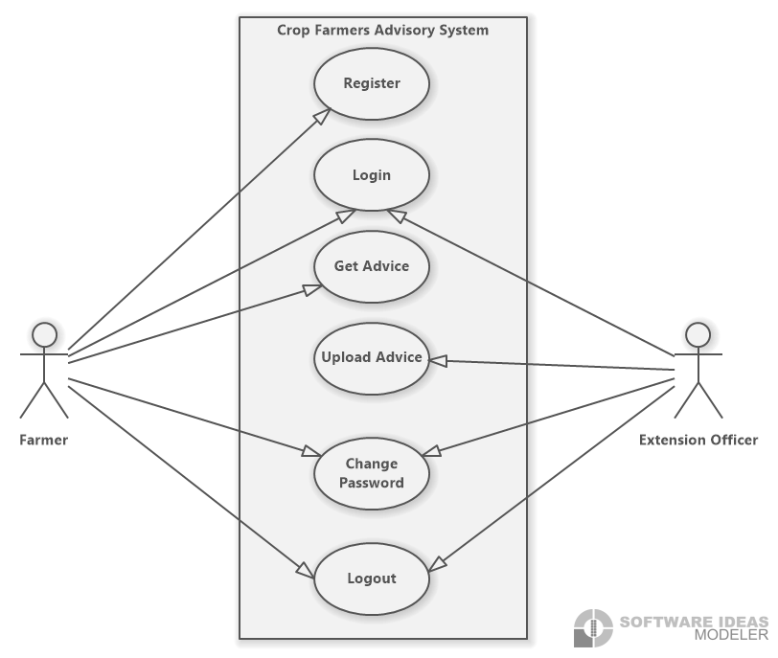

1. Sequence diagram-It was used to depict the interaction between objects in sequential order.

### The farmer and the extension officer interact with the system.

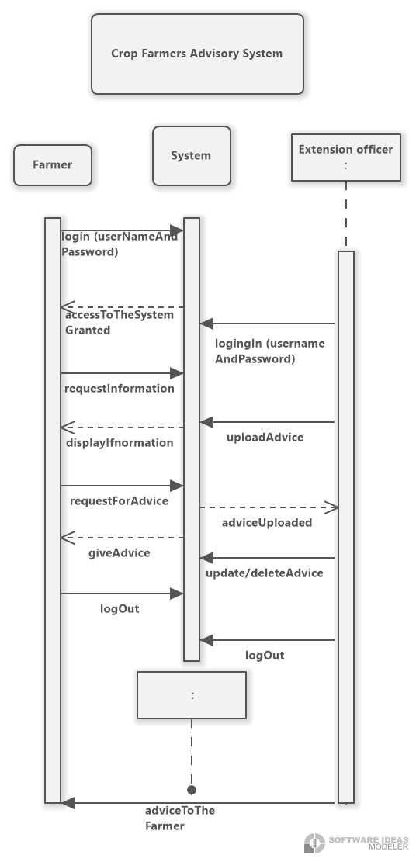

## 3.5 System design

It is a process of planning a new business system or replacing an existing system by defining its components or modules to satisfy specific requirements.

### 3.5.1 Database design

Database design is part of designing, developing, implementing, and maintaining data management systems. The primary goals of DBMS database design are creating logical and physical design models of the proposed database system. Entity Relationship Diagram (ERD) was used to map the connections between the various components of this system.

#### 3.5.1.1 Entity relationship diagram (ERD)

A database's foundation is an Entity Relationship Diagram (ERD). The entities to be stored, their attributes, and their relationships to one another can all be outlined in an Entity Relationship Diagram. This is an Entity Relationship Diagram depicting the relational database architecture of this scheduling application.

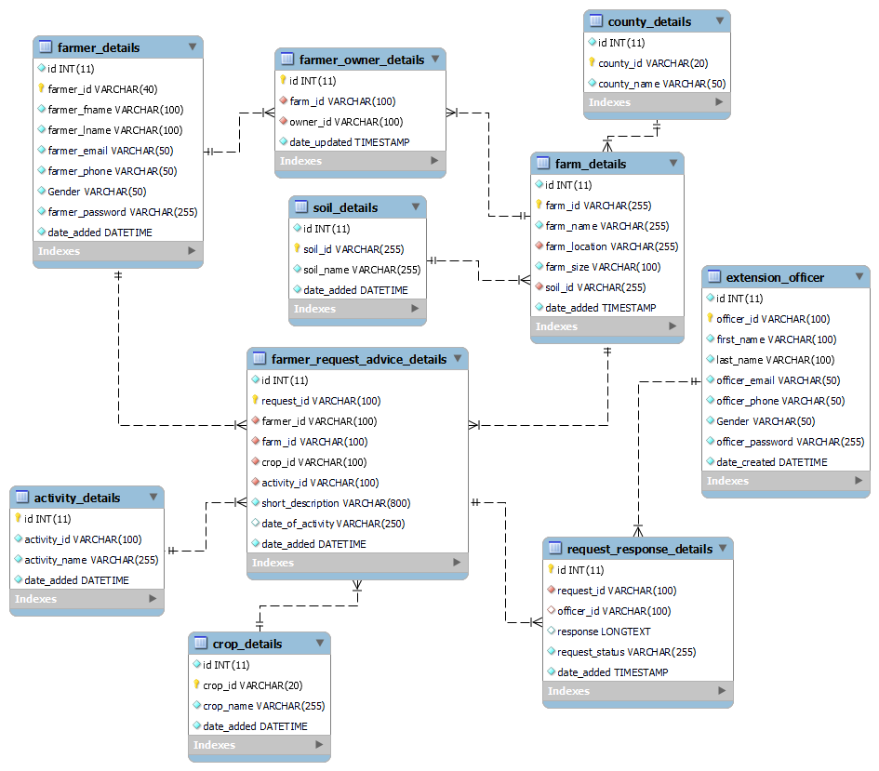

Figure 1 Entity Relationship Diagram

### 3.5.2 Input design

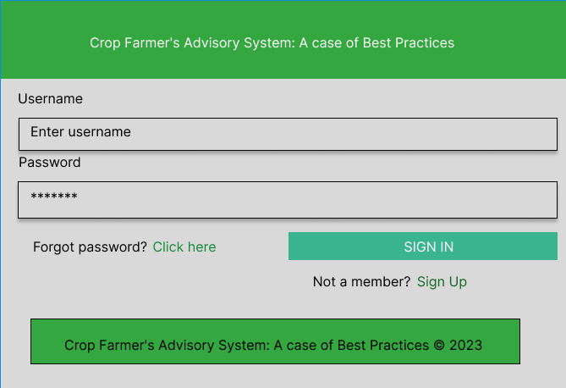

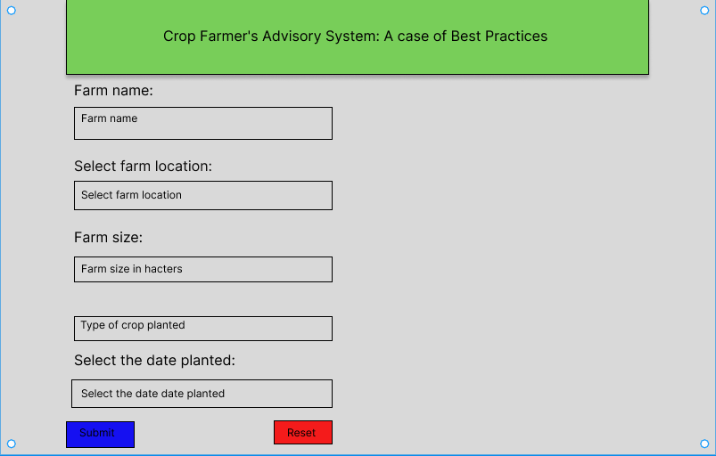

### 3.5.3 Output design

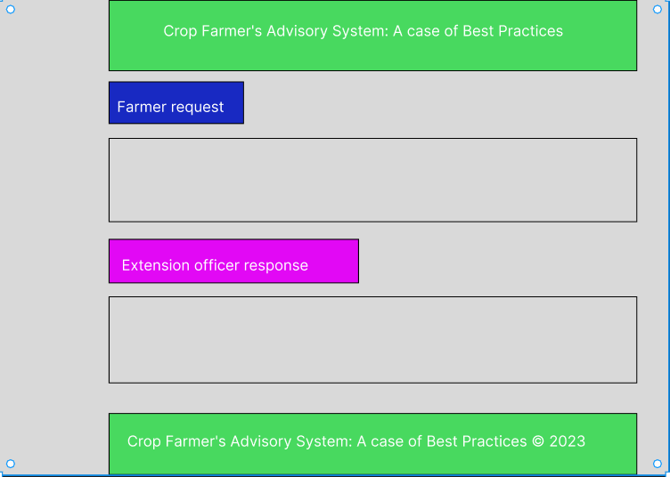

### 3.5.4 Reports design

#### 3.5.4.1 Farmer report design

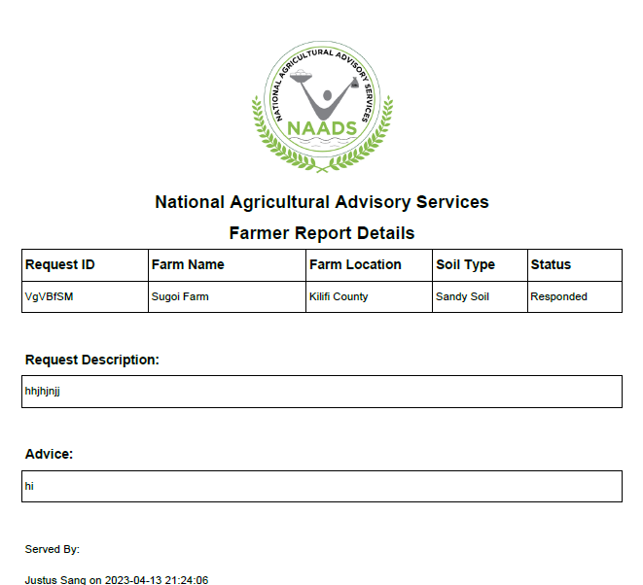

#### 3.5.4.2 Officer report design

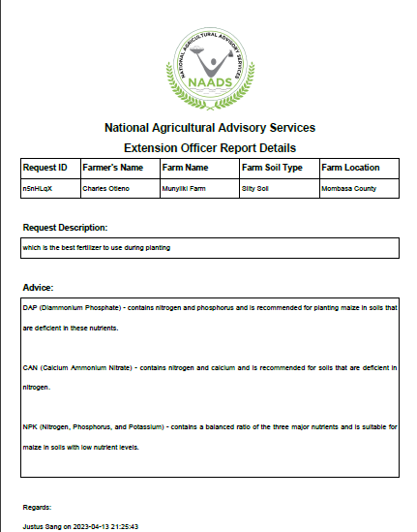

#### 3.5.1.1 Hardware specifications

##### Table 1 Hardware specifications

|  |  |
| --- | --- |
| Hardware | Specifications |
| Clock speed | 2.40HZ speed |
| Memory | 4 GB RAM |
| Disk space | 60 GB HDD |
| Processor | Intel corei5 |

The above hardware requirements were not the only specifications under which the proposed System could have been built, but the computer specifications that would be used. The prototype was hosted after development; thus, it relied on something other than the computer's specifications that intended to use the software.

#### 3.5.1.2 Software specifications

##### Table 2 Software specifications

|  |  |
| --- | --- |
| Software | Specifications |
| Operating System | Window 7 or later |
| Database Management System | MySQL |
| Run-time Environment | Visual Studio Code |

The proposed System was developed under the above-defined software environment for effective performance. Vscode editor was a very user-friendly and helpful text editor used by developers to build software. MySQL was used as the DBMS. After development, the prototype was deployed in shared hosting so everyone online could access the service. For the operating System, the computer used to develop the prototype ran on Windows Operating System.

## 3.6 Testing

Software testing was used to determine if the software product complied with expectations and was error-free. It entailed using human or automated software to assess one or more properties of interest. The goal of software testing was to find flaws, gaps, or unmet requirements compared to the requirements as written. Software Testing was necessary because any bugs or errors in the software could be identified early and solved before the software product delivery. An adequately tested software product ensured reliability, security, and high performance, resulting in time-saving, cost-effectiveness, and customer satisfaction;

1. The unit testing technique tested each component of the System. Each part was independently tested to check its performance. There was a checklist of all the elements and the requirements expected from each component. The primary goal of unit testing was to separate written code for testing to see if it functioned as intended. Unit testing was a crucial stage in the development process because, when done correctly, it could aid in finding early code issues that could be more challenging to identify in subsequent testing phases.

The evaluation checks for:

I. Whether the required functionality was available and working as expected.

II. How secure was the component?

III. Whether the response time was within the acceptable time limits.

1. The integration testing was the integration of the components to test their working. Next, the pieces were assembled to verify how well the parts were internetworking. At that stage, a performance test of the whole System was conducted after building the components, its security, whether the required functionalities were working correctly, and whether the parts were still working within the acceptable time limits ensuring there were no errors. Integration testing ensured the integrated units functioned correctly and aligned with stated requirements. It also ensured there were no errors between different modules' interfaces.
2. System testing tested the System in a pseudo environment. First, an environment resembling a typical launched system was set. The system performance was tested at this step, as the extreme load it can handle, stress testing, and scalability. Next, it entailed testing fully integrated applications, including external peripherals, to check how components interacted with one another and the System—verification through testing every input in the application to check for desired outputs. Finally, testing the user's experience with the application ensures the deployed software works as anticipated and meets the specified requirements.

**3.7 Significance**

System Testing entailed testing fully integrated applications, including external peripherals, to check how components interacted with one another and the System. Verify through testing every input in the application to check for desired outputs. Testing of the user's experience with the application; ensures that the deployed software works as anticipated and meets the specified requirements.

## 3.8 Representation of results

Screenshots of the software at various stages and screenshots of several modules, if not all, within the System, were used to demonstrate the proposed System's final output. In addition, having the System hosted and given its domain name made it possible for anyone to access it online and provide feedback on the System's usability and design.

## 3.9 Ethical requirements

The following are the ethical requirements of a crop farmers’ Advisory System

1. Privacy and confidentiality: Crop farmer advisory systems may collect sensitive information about farmers, such as crop yields, farming practices, and financial information. It is essential to ensure that this information is kept confidential and only used for the intended purposes of the system. Farmers should be informed about how their data will be collected, stored, and used and given the option to opt out of data sharing.
2. Transparency and informed consent: Farmers should be fully informed about the advisory system's goals, risks, and benefits before using it. They should be provided with clear and accurate information about the services provided, fees charged, and any conflicts of interest that may arise. Farmers should also be allowed to provide informed consent before sharing their data or receiving advice.
3. Fairness and non-discrimination: Crop farmer advisory systems should be designed and implemented reasonably not to discriminate against any particular group of farmers. Farmers should be treated equally, regardless of race, gender, ethnicity, or socio-economic status. The system should also avoid exacerbating existing inequalities or creating new ones.
4. Quality of advice and accountability: Crop farmer advisory systems should provide accurate, reliable, and relevant advice to farmers. The advice should be based on sound scientific knowledge and best practices and consider each farmer's specific context and needs. The system should also be accountable for the quality of its advice and provide mechanisms for farmers to provide feedback and report any issues or concerns.
5. Sustainable and environmentally responsible practices: Crop farmer advisory systems should promote sustainable and environmentally responsible farming practices, such as minimizing harmful chemicals, reducing greenhouse gas emissions, and conserving natural resources. The system should also consider the long-term impacts of its advice on the environment and encourage farmers to adopt practices that benefit their farms and the broader ecosystem.

Overall, ethical considerations are critical in designing and implementing crop farmer advisory systems that are effective, fair, and sustainable. By following best practices and consulting with relevant stakeholders and experts, it is possible to create a system that benefits farmers and the wider community.

# References

Chan, C., 2019. A system study on Lokal Lab and Lokal Siargao.. pp. 50-62.

Foor, A. t. B. a., 1986. Sampling methods. pp. 50-63.

Higgins, V. a. B. M. 2. F. a. g. I. s. t. f. a. s. f. i. S. R. 6. p.-4., 2020. *Framing agri‐digital governance: Industry stakeholders, technological frames and smart farming implementation. Sociologia Ruralis.* [Online]   
Available at: https://onlinelibrary.wiley.com/doi/abs/10.1111/soru.12297   
[Accessed 2 12 2022].

Jayne, 2019. Percentage of small-scale farmers. pp. 75-79.

MacCallum, R. C. W. K. F. Z. S. &. H. S. (. S. s. i. f. a. P. m. 4. 8., 1993. Sample size. *British medical jorunal,* pp. 1181-1184.

MWOBI, A., 2021. ONLINE CROP ADVISORY SYSTEM. pp. 14-18.

Sung, Y., 2018. SMART FARM REALIZATION BASED ON DIGITAL TWIN.. pp. 40-50.

# APPENDICES

## GANTT CHART

|  |  |  |  |  |  |  |  |  |
| --- | --- | --- | --- | --- | --- | --- | --- | --- |
| Weeks  Deliverables | Wk. 1 | Wk. 2 | Wk. 3 | Wk. 4 | Wk. 5 | Wk. 6 | Wk. 7 | Wk. 8 |
| Formulating Problem Statement and objectives |  |  |  |  |  |  |  |  |
| Numbering of the objectives well |  |  |  |  |  |  |  |  |
| Conduct a literature review (Chapter 2) |  |  |  |  |  |  |  |  |
| Identify common weaknesses across the reviewed systems. |  |  |  |  |  |  |  |  |
| Conduct methodology (Chapter 3) |  |  |  |  |  |  |  |  |
| Common weakness(Summary) |  |  |  |  |  |  |  |  |
| Roles played by SDLC & UML. Clarify differences between unit and module, and Correct the references. |  |  |  |  |  |  |  |  |
| Revised based on discussion and print two copies + CD |  |  |  |  |  |  |  |  |